**Decentralized Identity Implementation of C-Card**

Since the emergence of Internet applications in the last century, digital identity has developed with the development of the Internet. Digital identity may be email address, IP or domain name, QQ / Wechat account, Netease game account, Facebook account, Twitter account, etc., which are usually provided by Internet application service providers. Generally, different application service providers have different digital identities.

**Disadvantages of Traditional Digital Identity**

With the vigorous development of computer science technology and Internet applications, more and more work and life are online, and more and more people migrate from the physical world to the digital world, the application service provider centered account management also exposes more and more disadvantages:

1. Causing data island. Digital identity is subordinate to service providers, which determines that users need to register many accounts and passwords repeatedly. Each user produces data on different service providers, and the data on different service providers are not interconnected or difficult to circulate.
2. Create data monopoly. Internet giants monopolize the market by relying on the platform effect and use user data as a moat to generate a lot of value. However, users have no voice and value distribution for their own data. What's more, there is the phenomenon of Big Data Price Discrimination on the platform.

3. The problem of data privacy security. for example, Facebook has repeatedly exposed the problem of user data leakage. In daily life, all kinds of data leakage, collection and trading behavior can not be prevented, damaging the interests of users.

4. The ownership of digital identity. The digital identity is controlled by the service provider. The user rents and uses it. There is no ownership but the right to use it. The service provider can decide to disable the account, terminate the service, etc.

**ComingChat's Decentralized Digital Identity Solution: CID**

In order to solve these problems, ComingChat has provided a decentralized digital identity solution: CID (Coming ID, hereinafter referred to as CID). CID is a 1-12 digit number stored in the MinixChain with NFT attribute. Each CID can be bound with data. CID and its attached data can be traded and circulated in the MinixChain.

CID has the following advantages:

1. It is decentralized. CID is stored on the blockchain to avoid identity data being controlled by a single centralized organization.

2. The ownership belongs to the user. The digital identity is independent and controllable, the ownership of personal digital identity and associated data belongs to the user, and the user can choose to trade freely.

3. To protect the privacy and security of users. Users no longer need to worry about the leakage of personal information. As long as they do not disclose their private key, the data will not be disclosed.

4. It is a trusted data exchange. Since identity related data is stored on the blockchain, the authentication process will no longer rely on centralized institutions.

5. The data can be interconnected. Through cross chain and other technologies, the user's identity data can be used between different blockchains, avoiding the traditional repeated operation of registering multiple accounts with different service providers.

In order to understand more detailed CID implementation scheme, we need to understand MinixChain first. MinixChain is an open alliance chain based on the framework of Substrate and the consensus of aura + grandpa. Later, it will be derived into a parallel chain of ChainX through spider cross chain protocol. In order to prevent DDoS attack on the chain, Mini points will be issued as the service charge of the alliance chain.

User registers CID means that a transaction is initiated on MinixChain. After the transaction is confirmed on the chain, the CID is officially generated, and the ownership belongs to the user.

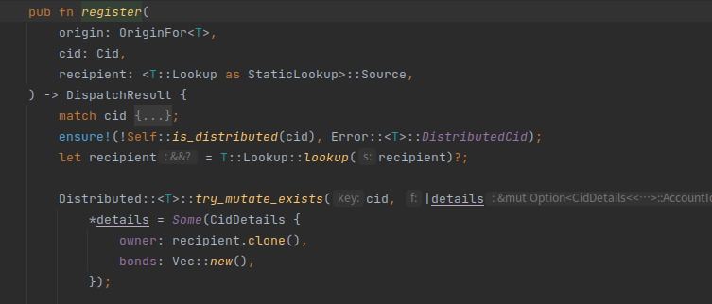

The process of transferring CID to others is also to initiate a transaction. Similarly, after the transaction is confirmed on the chain, the ownership of CID is transferred to the target user.

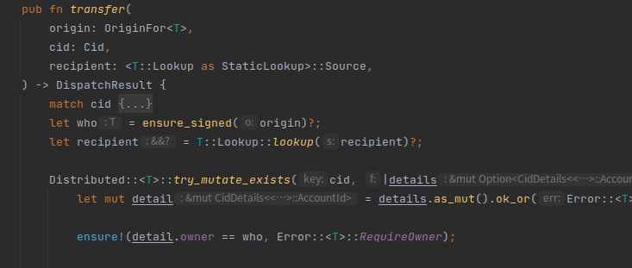

The C-Card provided by ComingChat is implemented based on CID. The data of each C-Card is bound with the corresponding unique CID, and all data is stored on the blockchain. CID is unique, so c-card is also unique. The data contained in C-Card includes card name, card face, issuer, watermark and so on. All data are stored on the chain. Once issued, it can not be tampered with, and the ownership belongs to the user, the user can trade freely.

1. Card example:



**Advantages of CID Over Other Decentralized Digital Identities**

At present, there are many decentralized digital identity (DID) projects in the market, such as WeIdentity, Baidu DID and so on,This kind of DID solution has the following disadvantages:

1. Very poor readability, similar to

did: ethr: 0xf96486a6b0b77ca91ac59da659358fd5ead16557,

this kind of identifier is very difficult to remember.

2. DID can only be stored in the specific blockchain of the DID issuer, can't cross chain, or difficult to cross chain.

3. This kind of DID solution is not verified by actual products and users, only stays in the conceptual stage or internal stage.

Now, let's take a look at the advantages of CID, a DID solution provider by ComingChat:

1. CID is a 1-12 digit number, similar to QQ number, easy to remember, and users can get rare CID by participating in community co construction, special contribution and other ways, which is of great commemorative and collection value.

2. CID is based on MinixChain alliance chain. As more and more members join the alliance chain, CID will support more and more service providers.

3. The bottom layer of MinixChain is Substrate, which naturally supports cross chain. CID will complete the cross chain function in the future. Users can cross the CID on the MinixChain to other blockchains, so that users with private keys of other blockchains can also use CID.

4. At present, ComingChat has about 60000 users, and the number of users is still growing, which indicates that CID has passed the actual test of tens of thousands of users, most users have expressed great interest in CID, and the number of CID transactions is also increasing every day.

5. CID is used as the identity of ComingChat. Users can use all services provided by ComingChat with CID.

With the continuous development of blockchain technology and the continuous improvement of related ecosystem, the era of Web3.0 is accelerating, and more and more Dapps will enter the production and life of the majority of users. We are committed to building a Web3.0 world, and we will implement an intelligent small program platform in ComingChat in the future. For individual users and enterprise users, using CID, you can create all kinds of Dapps and use all kinds of services on the platform. CID will become the pass of Web3.0 world!

Come to register your own CID, get your own C-Card, and become a person with digital identity in the era of Web3.0. Enjoy the next generation of Value Internet!